Paul Doyle

N00193346

Software Design and Development

CA 1

Contents

Case Diagram 3

Functional Requirements 3

Sequence Diagrams 4

Successfully Completed: 6

Partially Completed: 7

# Case Diagram

Figure 1: Case Diagram

# Functional Requirements

1. The stock taker can search for any drink by ID.
2. The stock taker can create a new drink.
3. The stock taker can view all drinks.
4. The stock taker can delete a drink by ID.
5. The stock taker can update a drink’s price by name.
6. The stock taker can update all drink properties.
7. The employee can view all drinks.
8. The employee can search for a drink by name.
9. The employee can update the stock of the drink by name.

# Sequence Diagrams

Figure 2: Create Drink

Figure 3: View(read) Drink

Figure 4: Update Drink

Figure 5: Delete Drink

# Successfully Completed:

1. Create new drink.

This function starts by first asking the user to input the information needed from which it then creates an object using a default constructor. Once this object is created, it passes the information to the database using the addDrink model.

1. View all drinks.

This function first creates an empty array which it will use to store all of the drink objects. The function will then loop the SQL query, collecting all of the data from the database, storing each row into an object. Once all the information has been pulled from the database, it will be printed to the console for the user.

1. Delete a drink by ID.

The function starts by asking the user to input an D. The function then uses the id in a sql statement to delete the drink object with the same ID

1. Update a drink.

This function starts by first asking the user to input the ID of the Drink they would like to update, the asks for rest of the drink information to be updated. It then uses the updateDrink model to overwrite the information previously stored in the update.

1. Update a drink’s stock.

The function asks for the drink ID, then asks the use for the new number of stock of this drink object. The updateDrinkStock model uses an SQL query to update the stock of the object with the ID given by the user.

1. View drink by name.

This function takes a name input from the user. It creates an array to put the results for the SQL query, but only one result will be put into the array. The array will then be displayed to the user.

# Partially Completed:

1. Delete drink (alternative).

The first version of my delete drink simply asks the user for the drink’s ID, then deletes the drink. I tried to implement a second version where the user inputs the ID, the drink to be deleted is then displayed to the user along with a prompt asking the user if they are sure they want to delete the drink. After the pressing the prompt, the drink is deleted.

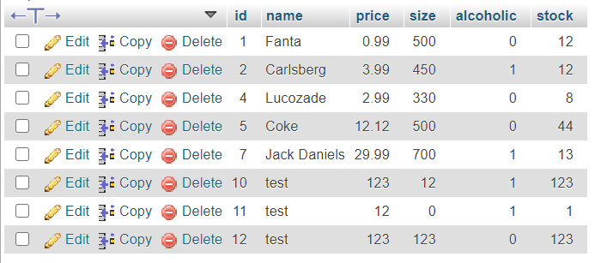

Figure 6: Table before delete

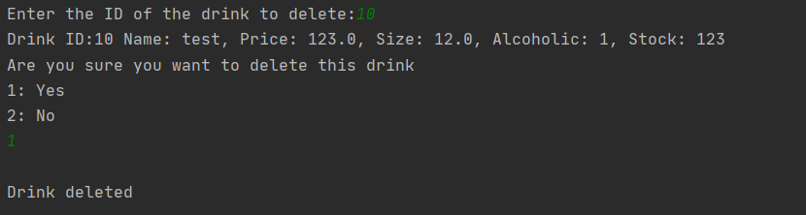

Figure 7: Delete Console log

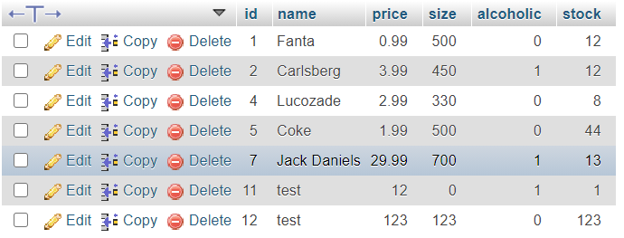

Figure 8: Table after Delete

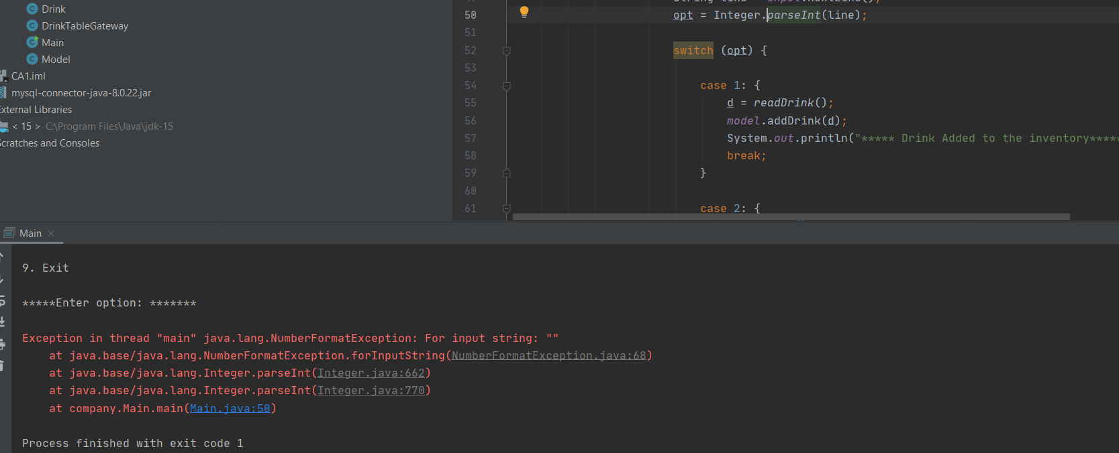

Figure 9: Delete Error

I have this function working, meaning it deletes the drink from the database, but after the function completes it crashes the program. The crash is somehow related variable used for the switch, but after troubleshooting and debugging I cannot find the cause of the error. I suspected that the error was related to my nested switch statements but removing the nested switch statements still cause the error.

1. Update Drink price

This update drink price has the same error as my alternative delete function, despite the function itself working and changing the data.

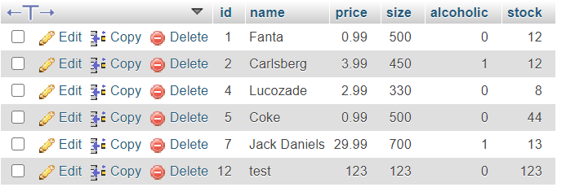

Figure 10: Table before Update Price

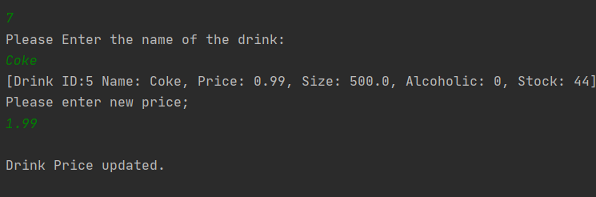

Figure 11: Console Update Price

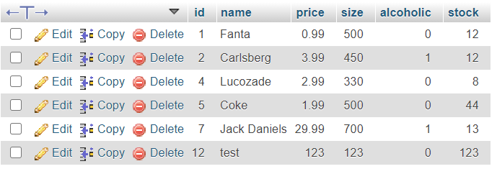

Figure 12: Table after Update Price

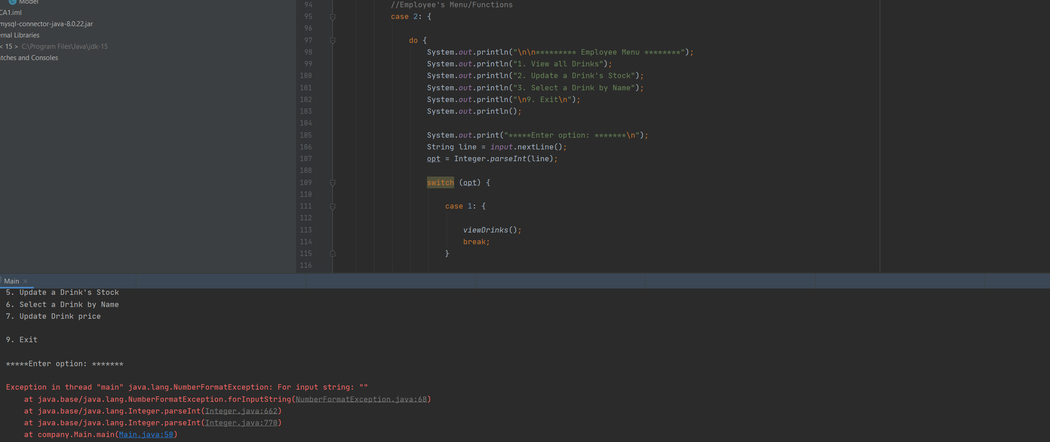

Figure 13: Console Error after Update Price